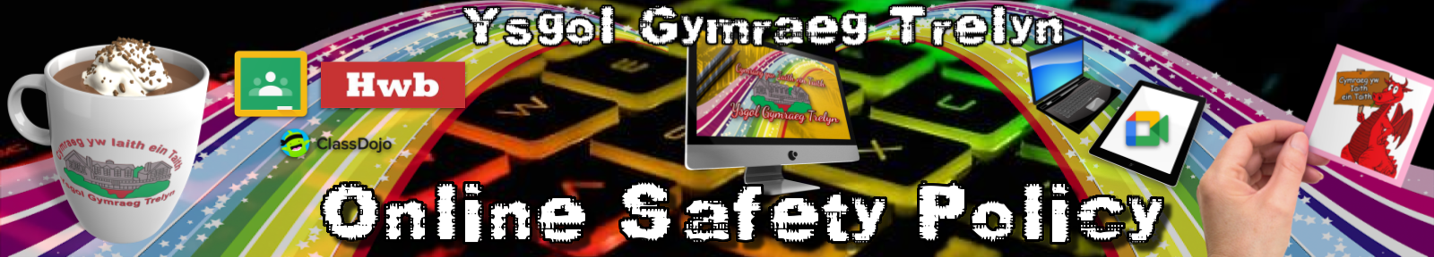



Pupil Acceptable Use Policy

This is how we stay safe when we use computers:

- I will ask a teacher or suitable adult if I want to use the computers/tablets.
- I will only use activities that a teacher or suitable adult has told or allowed me to use.
- I will take care of computers/tablets and other equipment.
- I will ask for help from a teacher or suitable adult if I am not sure what to do or if I think I have done something wrong.
- I will tell a teacher or suitable adult if I see something that upsets me on the screen.
- I know that if I break the rules I might not be allowed to use a computer/tablet.

Signed (child):

Every effort has been made to ensure that the information included in this document is accurate, as at the date of publication in February 2022.

